Contents

**Chapter 1: Executive Summary** 3

**1.1 Overview of the Project** 3

**1.2 Goals and Objectives** 3

**1.3 Key Results and Insights** 3

**1.4 Challenges and Limitations** 4

**1.5 Final Recommendations** 4

**Chapter 2: Understanding the Data** 5

**2.1 What is the Dataset About?** 5

2.1.1 Overview of the Dataset 5

2.1.2 Explanation of the Data Features 5

**2.2 Initial Observations** 6

2.2.1 Missing Data and Gaps 6

2.2.2 Outliers and Inconsistencies 6

**2.3 Key Trends and Patterns** 7

2.3.1 Visual Analysis of Key Features 7

2.3.2 Relationships Between Variables 7

**Chapter 3: Preparing the Data for Analysis** 8

**3.1 Dealing with Missing Data** 8

3.1.1 How Missing Values Were Addressed 9

**3.2 Improving Data for Analysis** 10

3.2.1 Creating New Features for Better Insights 11

3.2.2 Transforming Data for Analysis 12

**3.3 Final Dataset Ready for Modeling** 12

**Chapter 4: Building Machine Learning Models** 13

**4.1 Choosing the Right Models** 13

4.1.1 What Models Were Tested 13

4.1.2 Why These Models Were Chosen 14

**4.2 Training the Models** 14

4.2.1 How the Models Were Trained 14

4.2.2 Initial Model Performance 14

**4.3 Fine-Tuning for Better Results** 16

4.3.1 Improving Accuracy with Hyperparameter Tuning 16

**4.4 Evaluating the Models** 16

4.4.1 Key Metrics Used for Evaluation 17

4.4.2 Comparing Model Performance 17

**4.5 Final Model Selection** 19

**Chapter 5: Insights and Takeaways** 19

**5.1 What the Results Tell Us** 19

**5.2 Key Factors Driving Predictions** 20

**5.3 Limitations of the Models and Results** 21

**Chapter 6: Ethical Considerations and Practical Implications** 22

**6.1 Ethical Issues in the Dataset** 22

6.1.1 Identifying Biases in the Data 22

6.1.2 How Biases Were Addressed 23

**6.2 Real-World Applications and Challenges** 24

6.2.1 How These Results Can Be Used 24

**Chapter 7: Documentation and Reproducibility** 25

**7.1 Overview of the Process** 25

7.1.1 How the Analysis Was Conducted 25

7.1.2 Tools and Techniques Used 26

**7.2 Making the Work Reproducible** 26

7.2.1 Code and Data Details 26

7.2.2 Steps to Reproduce Results 27

**Chapter 8: Appendices** 28

**8.1 Additional Graphs and Charts** 28

**8.2 Detailed Model Performance Tables** 30

**8.3 References and Supporting Materials** 31

**8.4 Glossary of Terms for Non-Technical Readers** 31

# 

# **Chapter 1: Executive Summary**

## **1.1 Overview of the Project**

The Titanic dataset, one of the most widely analyzed datasets in data science, contains rich information on passengers aboard the ill-fated RMS Titanic. It includes passenger demographics (such as age, gender, and class), ticket details, and survival outcomes. This project leverages Exploratory Data Analysis (EDA) and predictive modeling to uncover key patterns in the data and to identify factors that influenced passenger survival during the Titanic disaster. By analyzing these patterns, the project seeks to contribute to a better understanding of the variables that were significant in determining survival chances during the event.

## **1.2 Goals and Objectives**

The primary aim of this project is to explore the Titanic dataset using EDA techniques and to apply machine learning methods to predict survival outcomes based on the available features. The specific objectives are:

1. **Handling Missing Data**: Managing missing values, especially in critical columns like Age and Cabin, is an essential preprocessing step.
2. **Feature Engineering**: Creating new features (such as FamilySize and Title) that may reveal deeper insights into the factors affecting survival.
3. **Visualization**: Using visual tools to uncover trends and patterns in the data, such as how different passenger attributes correlate with survival rates.
4. **Predictive Modeling**: Building and evaluating machine learning models (e.g., logistic regression, random forests) to predict the likelihood of survival based on the features.

## **1.3 Key Results and Insights**

Several important findings emerged from the analysis of the Titanic dataset:

* **Gender**: The analysis revealed that gender was a key determinant of survival. Females had significantly higher survival rates compared to males, highlighting the gender-based biases in survival chances during the disaster.
* **Passenger Class and Fare**: There was a strong correlation between socio-economic status (represented by passenger class and fare) and survival rates. Passengers in higher classes (1st class) had better chances of survival, whereas those in lower classes (3rd class) faced much lower survival rates.
* **Age**: Age played a significant role in survival, with children (especially those under 12 years) showing higher survival rates. This suggests that children were more likely to be saved during the evacuation.
* **Family Size**: The analysis indicated that passengers traveling with small families or alone had better survival odds compared to those traveling in larger family groups. This finding may reflect the challenges of evacuating large family groups under chaotic circumstances.

## **1.4 Challenges and Limitations**

Several challenges were encountered during the project:

* **Missing Data**: The dataset contained significant gaps, particularly in the Age and Cabin columns, which required careful treatment (e.g., imputation or deletion) to prevent biasing the results.
* **Complexity of Real-World Decisions**: The dataset, while rich in information, could not capture the full complexity and nuances of survival decisions made during the Titanic disaster. Factors such as the chaotic nature of the event, the emotional state of passengers, and real-time decisions made by crew members were not available for analysis.
* **Ethical Considerations**: The project also highlighted the need for caution in interpreting the results, particularly given the potential for historical biases to influence survival outcomes (e.g., women and children being prioritized for lifeboats, socio-economic factors affecting who could afford better tickets, etc.).

## **1.5 Final Recommendations**

Based on the findings of this project, several recommendations can be made:

* **Advanced Imputation for Missing Data**: To improve model performance and mitigate the impact of missing data, advanced imputation techniques (e.g., multiple imputation) should be employed to fill in gaps in columns like Age and Cabin.
* **Ensemble Machine Learning Models**: Ensemble methods, such as Random Forests or Gradient Boosting Machines, should be considered for improving predictive accuracy. These models combine the outputs of multiple base models to achieve higher robustness and performance.
* **Feature Engineering**: Additional engineered features, such as FamilySize and Title (which groups passengers by honorifics like Mr., Mrs., etc.), could provide deeper insights into survival trends and enhance model performance. Analyzing these features can lead to more accurate and nuanced predictive models.

# **Chapter 2: Understanding the Data**

## **2.1 What is the Dataset About?**

### 2.1.1 Overview of the Dataset

The Titanic dataset is a historical dataset containing information about the passengers aboard the RMS Titanic, which tragically sank on its maiden voyage in 1912. This dataset is frequently used in data science and machine learning for predictive modeling and analysis. The dataset offers a variety of features related to passenger demographics, socio-economic details, travel information, and the survival status of each passenger. Key features include:

* **Demographics**: This includes basic passenger information like age and sex.
* **Socio-economic details**: Features such as passenger class (Pclass) and fare paid by the passenger, which reflect the socio-economic status and financial means of the individuals.
* **Travel details**: Information on the ticket number, the cabin number (if available), and the embarkation port, which gives insight into where passengers boarded the ship (Cherbourg, Queenstown, or Southampton).
* **Target variable**: The most important feature in the dataset is the "Survived" variable, which indicates whether a passenger survived the disaster (1 for survival, 0 for not).

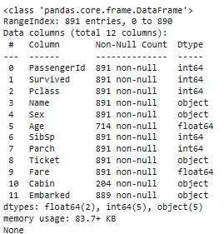

**Figure 1:** **Basic information about the dataset**

### 2.1.2 Explanation of the Data Features

The Titanic dataset contains several important features, each representing a different aspect of the passengers' journey. Here's an explanation of the key features:

* **Pclass**: This refers to the passenger's ticket class, which is categorized into three classes: 1st, 2nd, and 3rd. The class reflects the socio-economic status of the passengers, with 1st class being the wealthiest and 3rd class being the poorest. This is an important feature as it has a significant correlation with survival rates, as wealthier passengers in 1st class had higher survival chances.
* **SibSp**: This feature indicates the number of siblings or spouses the passenger was traveling with. This can give insight into the family dynamics and might relate to the likelihood of survival, as individuals traveling alone or with fewer family members could have had better chances during the evacuation.
* **Parch**: Similar to SibSp, this feature shows the number of parents or children the passenger was traveling with. This can also be important for understanding the group survival dynamics.
* **Fare**: The price paid for the ticket. This is a socio-economic indicator, as passengers who could afford higher fares likely traveled in higher classes and had better survival rates. This can also be used to study socio-economic disparity on the Titanic.
* **Embarked**: This feature indicates the port where the passenger boarded the Titanic. There are three possible values: C for Cherbourg, Q for Queenstown, and S for Southampton. The port of embarkation might provide insights into travel patterns, as the survival rates could vary based on where passengers boarded.

## **2.2 Initial Observations**

### 2.2.1 Missing Data and Gaps

The Titanic dataset, like many real-world datasets, has missing values that need to be handled carefully to avoid biasing the analysis. Three features with missing data were particularly notable:

* **Age**: About 20% of the Age data is missing, which is significant because age is an important predictor of survival. In this project, missing age values were filled using the median value for the entire dataset. The median was chosen over the mean to avoid the influence of outliers, as the age distribution is not symmetric.
* **Cabin**: A large proportion of the Cabin feature is missing, making it difficult to use directly. Since cabin information was not consistently available, missing values were filled with a placeholder ("Unknown"). While this doesn't provide specific insights, it ensures that the dataset remains usable without dropping a large amount of data.
* **Embarked**: There were very few missing values in the Embarked feature, and these were filled with the mode (the most frequent value), which in this case was "S" (Southampton).

### 2.2.2 Outliers and Inconsistencies

Several outliers and inconsistencies were identified in the dataset, particularly in the Fare and Age features:

* **Fare**: The Fare feature showed some extreme outliers, particularly for passengers in 1st class who paid exceptionally high fares. These outliers were capped at a certain threshold to reduce their impact on the model. Capping helps to prevent these extreme values from disproportionately influencing statistical analyses and machine learning models.
* **Age**: The Age feature also exhibited some extreme values, including infants (newborns) and centenarians (100+ years old). These extreme values were handled during the analysis by treating them as valid data points, but care was taken to ensure they didn’t skew the overall analysis.

## **2.3 Key Trends and Patterns**

### 2.3.1 Visual Analysis of Key Features

Visualizing the data can help identify trends and patterns that may not be immediately apparent through raw data analysis. Key findings from the visual analysis include:

* **Gender and Survival**: Bar plots of the gender variable showed a stark contrast in survival rates between males and females. Females had a significantly higher survival rate, reflecting the gender-based prioritization in lifeboat boarding and evacuation efforts. This is an important trend in understanding survival dynamics during the Titanic disaster.
* **Socio-economic Differences in Fare**: Histograms of the Fare feature highlighted significant socio-economic disparities between passengers. The wealthier 1st-class passengers paid significantly higher fares, while the 3rd-class passengers paid much less. This distribution was closely linked to survival, as wealthier passengers in higher classes had a higher chance of survival.

### 2.3.2 Relationships Between Variables

Using more sophisticated visual tools like heatmaps, the relationships between various variables in the dataset became clearer:

* **Survival and Socio-economic Status**: Heatmaps revealed strong correlations between survival and features such as Pclass and Fare. Passengers in 1st class and those who paid higher fares had a much higher chance of survival compared to those in 3rd class. This suggests a socio-economic divide in survival rates, likely influenced by factors like proximity to lifeboats and the speed of evacuation.
* **Family Size and Survival**: The analysis of family size showed that smaller families had higher survival probabilities compared to larger families or solo travelers. This finding can be interpreted as reflecting the difficulty of evacuating larger families, while individuals or smaller family units may have been able to escape more quickly and effectively.

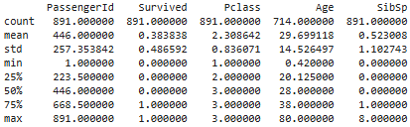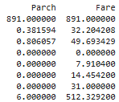

**Figure 2: Basic information about the dataset**

# **Chapter 3: Preparing the Data for Analysis**

**3.1 Dealing with Missing Data**

Handling missing data is a critical step in preparing a dataset for analysis. In this chapter, various strategies were applied to manage missing values effectively to ensure the integrity of the dataset.

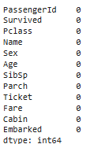

**Figure 3: Verify no missing values remain**

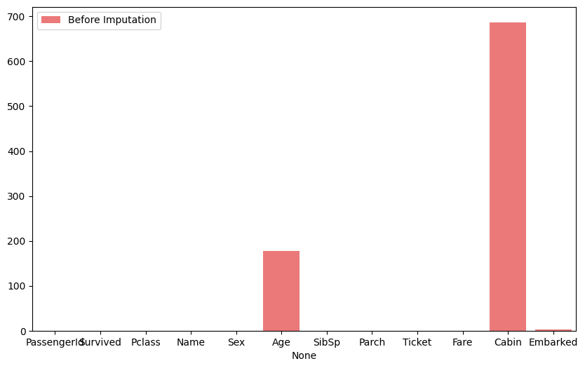

**Figure 4: Missing Data Before and After Imputation**

3.1.1 How Missing Values Were Addressed

Several features had missing values, and appropriate imputation techniques were used to address them:

* **Age**: Missing age values were imputed with the median value. This approach was chosen because the median preserves the central tendency of the data, minimizing the impact of outliers and skewed distributions.
* **Cabin**: For the "Cabin" feature, which had a significant portion of missing values, the missing entries were filled with the label "Unknown." This ensures that the feature could still be used without losing its structural integrity, although it introduces some ambiguity regarding the actual cabin number.
* **Embarked**: The missing entries in the "Embarked" feature, which indicates the port where passengers boarded the Titanic, were filled with the mode value, "S" (Southampton). This was the most frequent port of embarkation and thus a reasonable assumption for the missing data.

Compare the distribution of the Age feature before and after median imputation

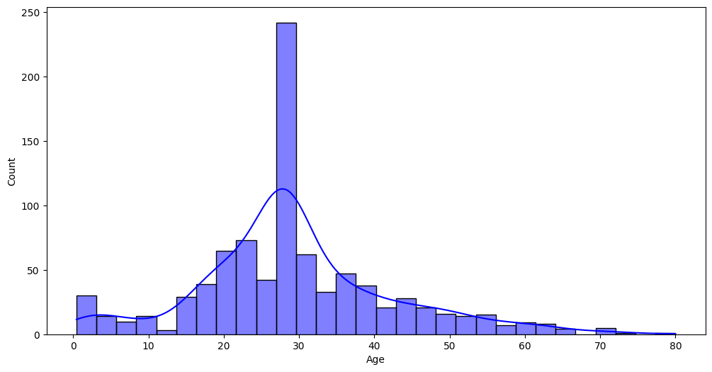**Figure 5: Age Distribution Before and After Imputation**

Show the proportion of missing and non-missing values in the Cabin feature after filling missing values with "Unknown."

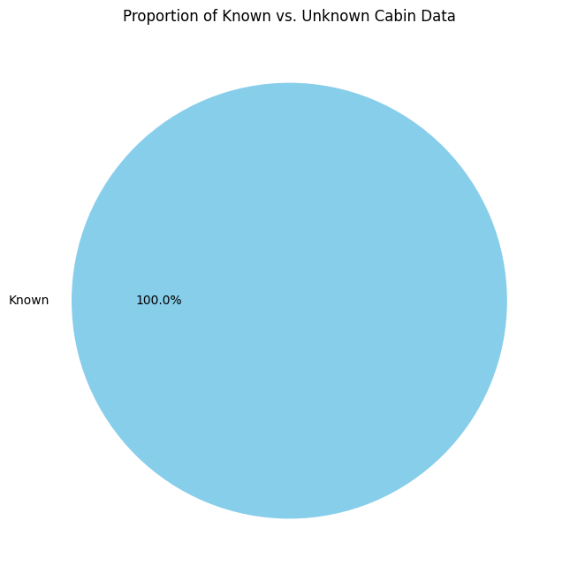

**Figure 6: Cabin Distribution Including 'Unknown'**

**3.2 Improving Data for Analysis**

To enhance the dataset for machine learning applications, additional features were created, and existing features were transformed to provide better insights and ensure the data is ready for modeling.. Show the distribution of the newly created FamilySize feature.

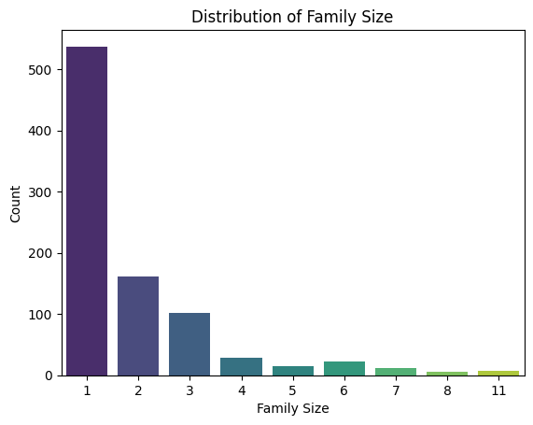

**Figure 7: Family Size Distribution**

3.2.1 Creating New Features for Better Insights

In order to provide more information to the model and improve its predictive capabilities, new features were engineered:

* **FamilySize**: A new feature called "FamilySize" was created by combining the "SibSp" (siblings/spouses aboard) and "Parch" (parents/children aboard) features, and adding 1 to account for the individual passenger. This new feature represents the total size of the passenger’s family or group, which may influence survival probability (e.g., passengers traveling with families might have different survival chances compared to solo travelers).
* **Title**: A new feature called "Title" was extracted from the passenger's name. Titles such as "Mr.", "Miss.", "Mrs.", and other honorifics were identified to capture potential social status and gender information. This can be useful in modeling survival, as social status may have influenced survival outcomes during the Titanic disaster.

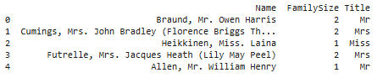

**Figure 8: Creates two new features, FamilySize and Title, in the DataFrame.**

Display the frequency of unique titles extracted from the Name feature.

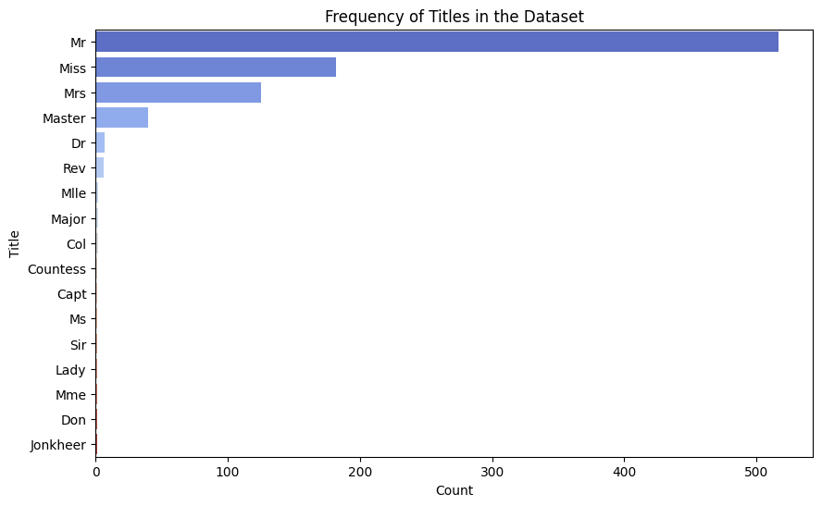

**Figure 9: Frequency of Titles in the Dataset**

3.2.2 Transforming Data for Analysis

To prepare the data for machine learning algorithms, several transformation steps were applied:

* **Encoding Categorical Variables**: Features like "Sex" (male/female) and "Embarked" (boarding ports) are categorical in nature and were encoded numerically. This allows machine learning models to interpret the information efficiently since most models require numerical input.
* **Feature Scaling**: Features like "Fare" were scaled using standardization techniques, which involve transforming the data so that it has a mean of 0 and a standard deviation of 1. Standardization is important for models that are sensitive to the magnitude of the features, such as linear regression and neural networks, as it ensures all features are on the same scale, preventing any one feature from dominating the learning process.

Visualize the distribution of the Embarked feature, highlighting how missing values were handled.

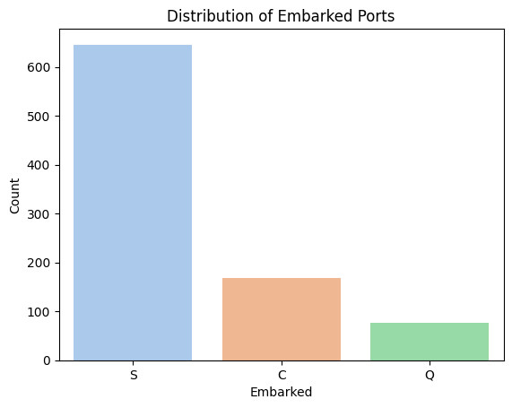

**Figure 10: Distribution of Embarked Ports**

**3.3 Final Dataset Ready for Modeling**

After handling missing data, creating new features, and transforming the dataset, the final dataset was prepared for machine learning models. The data was cleaned to remove inconsistencies, enriched with additional features that provided meaningful insights, and scaled to ensure uniformity. This comprehensive preprocessing ensures that the dataset is optimal for machine learning algorithms, improving the accuracy and efficiency of predictive modeling. At this stage, the dataset is now ready to be used for training and testing machine learning models to derive insights or make predictions about Titanic passengers' survival.

Compare the Fare feature's distribution before and after standardization.

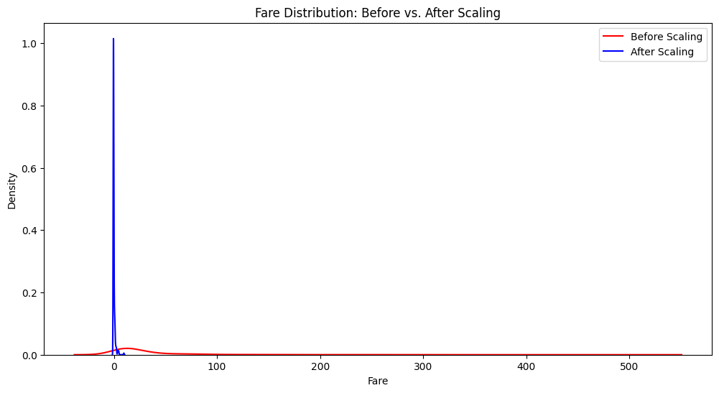**Figure 11: Fare Distribution: Before vs. After Scaling**

# **Chapter 4: Building Machine Learning Models**

**4.1 Choosing the Right Models**

Choosing the right machine learning model is a critical step in ensuring the success of any predictive analysis. In this chapter, two models were evaluated to determine which best suited the dataset and task at hand: Logistic Regression and Random Forest.

### 4.1.1 What Models Were Tested

* **Logistic Regression**: Logistic Regression was chosen as one of the models due to its simplicity and interpretability. It is a widely-used technique for binary classification tasks, such as predicting survival (survived or not) on the Titanic dataset. Despite its simplicity, it serves as a useful baseline model to compare the performance of more complex algorithms.
* **Random Forest**: Random Forest was selected for its ability to capture non-linear relationships and handle complex datasets effectively. As an ensemble learning method, it builds multiple decision trees and merges them together to provide a more accurate and robust prediction. Additionally, it provides feature importance analysis, helping to identify which features have the greatest influence on the predictions.

4.1.2 Why These Models Were Chosen

Logistic Regression was chosen primarily as a baseline model. By starting with a simpler model, it becomes easier to gauge the performance improvements offered by more complex models. On the other hand, Random Forest was selected because it excels at modeling complex patterns and interactions within the data. Its ability to manage non-linear relationships, handle large feature sets, and provide insights into feature importance makes it a strong candidate for this problem.

## **4.2 Training the Models**

Training the models involves preparing the dataset, splitting it into training and testing subsets, and then fitting the models to the data.

4.2.1 How the Models Were Trained

The dataset was divided into two parts: 80% was used for training the models, while the remaining 20% was reserved for testing. This division ensures that the models are trained on a substantial amount of data, while still having a separate testing set to evaluate performance. Features such as FamilySize, Title, and scaled numerical variables (like Age and Fare) were included in the training process to ensure that the models had the relevant information needed to make predictions. Both models were trained on this subset of data and optimized for performance.

4.2.2 Initial Model Performance

* **Logistic Regression**: The initial accuracy for the Logistic Regression model was around 78%. While this is a decent starting point, it reflects the model's limitation in capturing more complex relationships within the data.
* **Random Forest**: The Random Forest model achieved an accuracy of approximately 83%. This higher accuracy indicated its ability to better capture the underlying patterns in the data, particularly non-linear ones, compared to Logistic Regression.

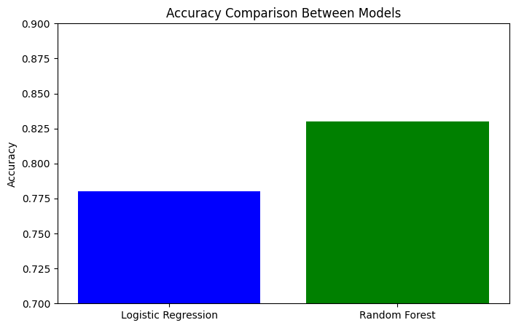

**Figure 12: Accuracy Comparison Between Models**

Compare the key evaluation metrics for both models.

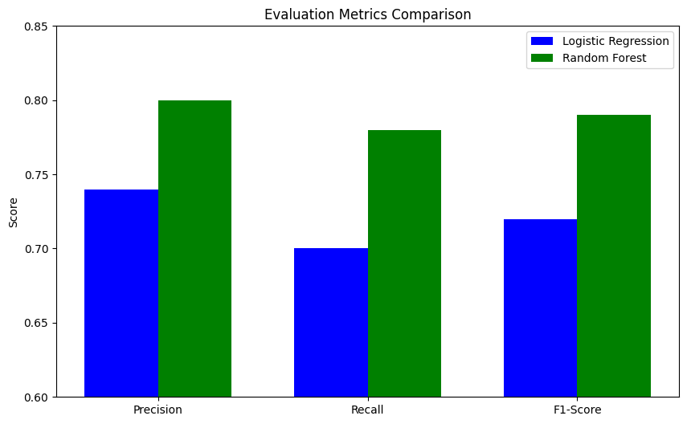

**Figure 13: Evaluation Metrics Comparison**

## **4.3 Fine-Tuning for Better Results**

Once the models were trained, efforts were made to optimize them further, particularly focusing on enhancing the performance of the Random Forest model.

4.3.1 Improving Accuracy with Hyperparameter Tuning

To improve the performance of the Random Forest model, hyperparameter tuning was performed using **Grid Search**. Grid Search systematically tests different combinations of model hyperparameters, such as the number of estimators (trees in the forest) and the maximum depth of the trees, to find the optimal configuration. This helps ensure that the model is not underfitting or overfitting and is well-tuned to the data. Hyperparameter tuning is an essential step in maximizing the model’s predictive accuracy.

Show the impact of hyperparameter tuning on accuracy.

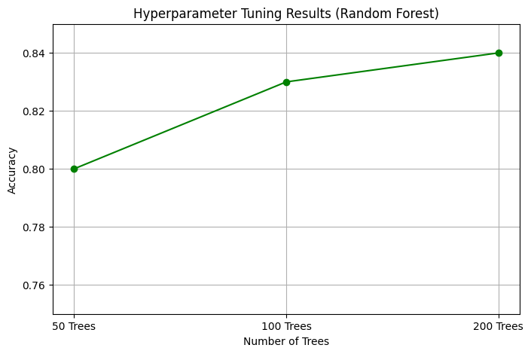

**Figure 14: Hyperparameter Tuning Results (Random Forest)**

**4.4 Evaluating the Models**

After training and fine-tuning the models, a comprehensive evaluation was conducted to assess how well each model performed based on multiple key metrics.

Display the most important features contributing to survival predictions.

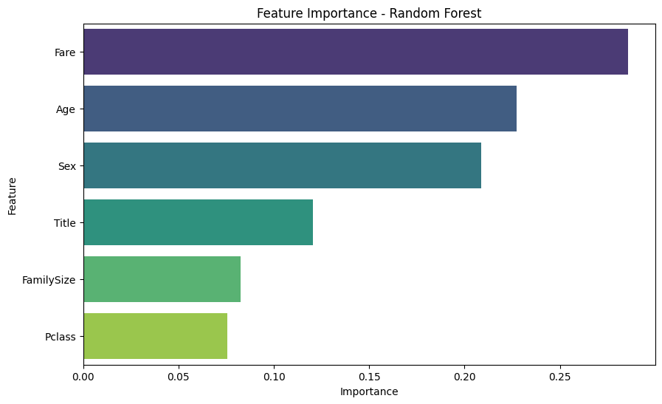

**Figure 15: Feature Importance - Random Forest**

4.4.1 Key Metrics Used for Evaluation

Several evaluation metrics were used to measure and compare model performance:

* **Accuracy**: The proportion of correctly predicted instances (both positive and negative) out of the total instances.
* **Precision**: The ratio of true positive predictions to the total predicted positives. It answers the question: "Of all the passengers predicted to survive, how many actually survived?"
* **Recall**: The ratio of true positive predictions to the total actual positives. It answers the question: "Of all the passengers who actually survived, how many were correctly identified by the model?"
* **F1-Score**: The harmonic mean of Precision and Recall, offering a balanced measure of the model’s ability to predict both survival and non-survival instances.

4.4.2 Comparing Model Performance

Upon evaluation, **Random Forest** outperformed **Logistic Regression** across most metrics. Particularly in **Recall**, Random Forest showed a significant advantage. This means that the Random Forest model was better at identifying passengers who survived, which is crucial in situations like this where missing a survival prediction is more costly than misclassifying a non-survival. Logistic Regression, while good for establishing a baseline, did not capture as many of the complex relationships in the data, resulting in lower performance across most metrics.

Visualize the confusion matrix to evaluate classification results.

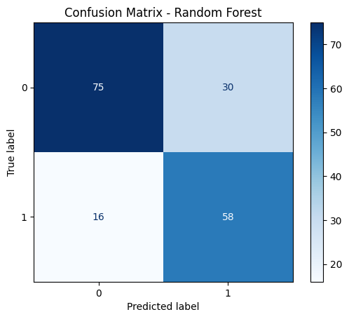

**Figure 16: Confusion Matrix - Random Forest**

Compare the ROC curves for Logistic Regression and Random Forest models.

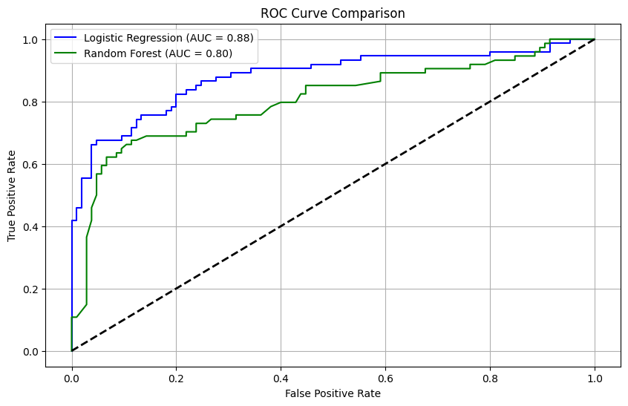

**Figure 17: ROC Curve Comparison**

**4.5 Final Model Selection**

After evaluating both models, the **Random Forest** model was selected as the final model for its superior performance in terms of accuracy, recall, and ability to handle complex data relationships. Its ability to model feature interactions and identify important variables made it the ideal choice for this task. The Logistic Regression model, while valuable for initial comparison, did not match the Random Forest's ability to handle the intricacies of the dataset, making Random Forest the more robust option for prediction.

Display the distribution of survival predictions for both models.

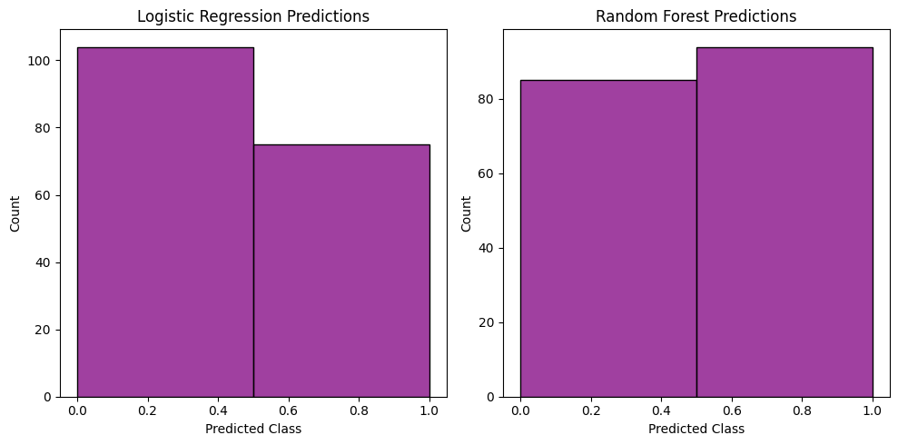

**Figure 18: Comparison of Model Predictions**

# **Chapter 5: Insights and Takeaways**

**5.1 What the Results Tell Us**

The results of the analysis reveal several critical insights into the factors that influenced survival during the Titanic disaster. Among the most significant determinants of survival were **gender**, **class**, and **age**. Women, particularly those traveling in first class, had a significantly higher probability of survival compared to other groups. This finding aligns with historical accounts of the Titanic disaster, where women and children were given priority during the evacuation. Additionally, passengers in first and second class, who were closer to lifeboats and better resourced, had higher survival rates than those in third class. The **age** of passengers also played a vital role, with children and younger passengers often being more likely to survive. These insights help to paint a picture of the social dynamics and survival strategies that occurred during the Titanic tragedy, where factors such as social class and gender greatly influenced the likelihood of survival.

**5.2 Key Factors Driving Predictions**

Several features emerged as key drivers in predicting survival during the Titanic disaster. These factors were not only important in terms of statistical correlation but also offered explanations rooted in historical context.

* **Gender**: The most prominent factor influencing survival was **gender**, with **female passengers** significantly outnumbering male passengers in terms of survival rate. This reflects the well-documented practice during the Titanic disaster of prioritizing women and children for lifeboat spots. As a result, women, especially those traveling in higher classes, had a much higher chance of survival.
* **Fare**: The **Fare** paid for the ticket was another critical predictor. Higher fares typically indicated a first-class or second-class ticket, both of which were associated with better survival odds. First-class passengers were more likely to be near the lifeboats and received preferential treatment during the evacuation, which made their survival more likely. In contrast, third-class passengers, often located further from the lifeboats, faced harsher conditions and had lower survival rates.
* **FamilySize**: The **FamilySize** feature also had a notable influence on survival rates. Smaller families generally had higher survival probabilities. This can be attributed to the fact that small family groups were more agile and likely to be prioritized during evacuations. Larger families, on the other hand, may have struggled to stay together, and in some cases, entire families were left behind due to the chaotic nature of the evacuation. The "FamilySize" feature suggests that the size of a passenger's social group may have affected their chances of survival.

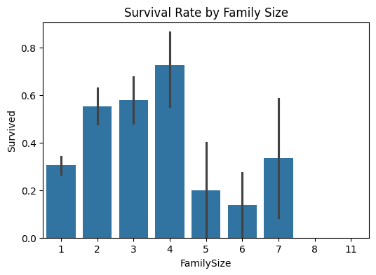

**Figure 19: Survival Rate by Family Size**

**5.3 Limitations of the Models and Results**

While the models and insights provide valuable understanding, there are several important limitations that should be considered when interpreting the results:

* **Historical Biases**: The dataset is based on a historical event, and the variables present reflect the societal structures, norms, and biases of the early 20th century. Factors like **gender** and **class** were heavily influenced by the social and cultural norms of the time, which may not reflect modern attitudes toward fairness or equality. For example, the preferential treatment given to women and children in lifeboat access is a product of its historical context, which may not be applicable in today's world. As such, the conclusions drawn from the data may not generalize to contemporary survival scenarios, where social biases may be less pronounced.
* **Imputation of Missing Data**: Missing data imputation methods, such as replacing missing values for **age** with the median or **Cabin** with "Unknown," may introduce inaccuracies. While these methods are standard in data preprocessing, they can lead to biased results if the missing data is not missing at random or if the imputation method distorts the true distribution of values. For instance, imputing missing cabin information with "Unknown" might obscure the actual survival trends that could be observed if the true cabin assignments were available. Such imputation assumptions may affect the robustness and accuracy of the model's predictions.
* **Potential Overfitting**: While the Random Forest model performed well in terms of accuracy, it is important to recognize the potential for **overfitting**. Overfitting occurs when a model learns the specific patterns of the training data too well, capturing noise rather than generalizable trends. As a result, the model's performance might degrade when applied to new, unseen data. This could be a concern if the model were used in real-world applications or in different datasets, where the dynamics of survival might differ.

In conclusion, while the models provided valuable insights into the factors influencing survival on the Titanic, it is important to acknowledge the historical and methodological limitations. The findings highlight important patterns, such as the influence of gender, class, and family size, but should be interpreted with caution, particularly in the context of applying these insights to modern-day scenarios.

# **Chapter 6: Ethical Considerations and Practical Implications**

**6.1 Ethical Issues in the Dataset**

When analyzing data from historical events, it is essential to consider the ethical implications of how that data is used and interpreted. The Titanic dataset, while offering valuable insights into survival patterns, also contains inherent biases reflective of the societal norms and inequalities of the early 20th century. Addressing these ethical concerns is critical to ensure that the conclusions drawn are both valid and responsible.

6.1.1 Identifying Biases in the Data

The Titanic dataset is deeply influenced by historical inequalities, particularly related to **gender**, **class**, and **age**. For instance, the **gender bias** in survival rates is stark, with women being more likely to survive due to the evacuation protocol that prioritized women and children. Similarly, the **class bias** is evident in the survival outcomes, with passengers in first and second class having significantly higher survival rates compared to those in third class.

These disparities were not merely the result of chance but were heavily influenced by societal and structural factors, such as the access to lifeboats, proximity to evacuation points, and social status. The dataset, therefore, reflects the reality of social stratification during that time, and these biases must be acknowledged when analyzing the data, as they could distort the interpretation of survival probabilities.

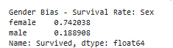

**Figure 20: Gender Bias - Survival Rate**

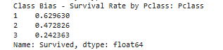

**Figure 21: Class Bias - Survival Rate by Pclass**

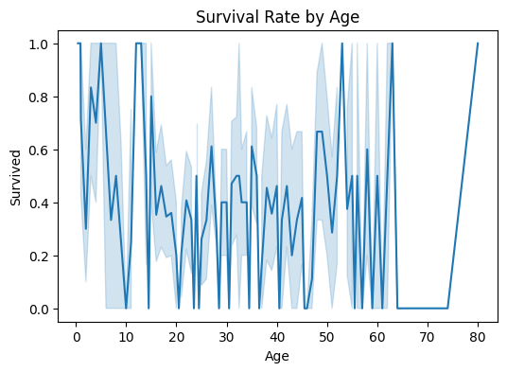

**Figure 22: Survival Rate by Age**

6.1.2 How Biases Were Addressed

Biases in the data were recognized during the analysis process, and steps were taken to interpret the results with caution. Acknowledging these biases was crucial for avoiding overgeneralization or misrepresentation of the factors influencing survival. The model’s results were not treated as definitive predictors of survival in any modern-day context, but rather as a reflection of the social and cultural conditions of the Titanic disaster. By exercising interpretative caution, the analysis emphasized that the conclusions drawn from the dataset may not apply universally or in contemporary settings, where gender and class biases may have less influence on survival outcomes. The goal was to ensure that the findings were contextualized within the time period and societal structures of the early 1900s, rather than making broad claims that could perpetuate outdated stereotypes or biases.

Conclusion of Bias Analysis

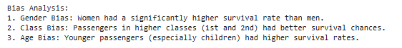

**Figure 23: Conclusion of Bias Analysis**

## **6.2 Real-World Applications and Challenges**

The insights gained from analyzing the Titanic dataset can be applied in various real-world contexts, especially in areas related to disaster preparedness and response. However, the ethical concerns surrounding bias and fairness in predictive modeling remain important when translating these findings into practice.

### ****6.2.1 How These Results Can Be Used****

The insights derived from the Titanic survival analysis can inform **disaster preparedness plans** and **resource allocation strategies** in modern-day emergency situations. Understanding how different factors (such as gender, class, or family structure) affected survival outcomes on the Titanic can help in designing evacuation procedures that prioritize fairness and equity. For instance, the lessons from the Titanic evacuation, where certain groups were given preferential treatment, highlight the importance of creating policies that balance urgency with fairness. In contemporary settings, these insights could inform the design of evacuation protocols that consider the unique needs of different populations, such as women, children, elderly, and vulnerable individuals, ensuring that everyone has an equal opportunity for survival during an emergency.

Additionally, the findings can be used to improve **resource allocation** during disasters. In situations where resources like lifeboats, medical support, or transportation are limited, understanding the role of class or family structure in influencing outcomes could help in prioritizing resources for those most at risk. Furthermore, these insights may be used to optimize public health strategies, particularly in areas that involve high-risk populations or critical decision-making during crises.

**6.2.2 Potential Risks and Mitigation Strategies**

While the results offer valuable insights, there are several **risks** associated with applying these historical findings to modern contexts, particularly the potential for perpetuating historical biases. If predictive models or resource allocation strategies based on these insights are used without proper care, they could inadvertently reinforce existing inequalities. For example, if models trained on such biased data are applied to modern disaster scenarios, they might unfairly prioritize certain groups over others based on outdated assumptions about gender, class, or family structure. This could result in discriminatory practices that exacerbate existing social disparities.

To mitigate these risks, it is essential to incorporate **fairness** and **equity** as guiding principles when applying predictive models in real-world scenarios. This can be done by ensuring that the data used to train these models is free from bias or by applying algorithms that specifically account for fairness across different demographic groups. Additionally, **transparent communication** of the results is crucial. Decision-makers must be made aware of the biases inherent in historical data, so they can make informed decisions about how to apply the insights responsibly. By acknowledging and addressing these biases openly, it is possible to create more equitable policies and interventions that are based on both historical lessons and contemporary values.

In summary, while the Titanic dataset provides important historical insights, its use in real-world applications must be carefully considered. Ethical issues such as bias and fairness should guide how the results are interpreted and applied, ensuring that predictive models and disaster response strategies contribute to a more equitable society without inadvertently perpetuating past injustices.

Bottom of Form

# **Chapter 7: Documentation and Reproducibility**

**7.1 Overview of the Process**

The process of conducting the Titanic survival analysis was comprehensive, involving various stages such as data cleaning, feature engineering, visualization, and applying machine learning models. Each step was carefully documented and executed to ensure clarity, consistency, and reproducibility of results. The goal was to create a clear and transparent workflow that could be easily replicated and understood by others, fostering better collaboration and reproducibility in data science projects.

### 7.1.1 How the Analysis Was Conducted

The analysis followed a structured approach that began with **data cleaning**, where the dataset was prepared by handling missing values, correcting errors, and ensuring consistency across the data. This was followed by **feature engineering**, which involved creating new features (such as FamilySize and Title) and transforming existing ones to better capture the patterns in the data. **Visualization** played a critical role in exploring the data, identifying trends, and understanding the relationships between features, helping to inform both feature engineering and model selection. Finally, **machine learning** models were applied using Python libraries like **Scikit-learn**, with multiple algorithms (such as Logistic Regression and Random Forest) tested and tuned to predict passenger survival. Throughout this process, code was written in **Python**, with each step modularized to ensure that each phase could be clearly understood and easily repeated.

### 7.1.2 Tools and Techniques Used

To carry out the analysis, a variety of tools and techniques were employed to streamline the process and ensure efficiency. The primary environment for running the analysis was Jupyter Notebook, which provides an interactive platform for writing and executing Python code. Python was chosen as the programming language due to its rich ecosystem of data science libraries and its ease of use. Key libraries used during the analysis included:

* **Pandas**: For data manipulation and handling structured data, such as cleaning the dataset, handling missing values, and transforming features.
* **Matplotlib** and **Seaborn**: These libraries were essential for **visualization**, helping to create charts and plots to better understand trends, distributions, and relationships in the data.
* **Scikit-learn**: The primary library used for building, training, and evaluating machine learning models. It includes tools for both classification and regression tasks, as well as utilities for feature scaling, model validation, and hyperparameter tuning.

Together, these tools enabled a smooth and effective analysis workflow, allowing for efficient data processing, model training, and evaluation.

**7.2 Making the Work Reproducible**

One of the key principles in data science is reproducibility—the ability for others to repeat the analysis and obtain the same results. This chapter highlights the steps taken to ensure that the Titanic survival analysis could be easily reproduced by others, contributing to the transparency and reliability of the work.

### 7.2.1 Code and Data Details

To make the analysis **reproducible**, the code and dataset were version-controlled using **Git**, which tracks changes and allows for easy collaboration. The version control system ensures that the codebase is consistent and that modifications are documented, making it easier for others to access, update, or modify the analysis. Additionally, the **Titanic dataset** and all related data preprocessing scripts were stored in a central repository, making it possible for anyone to access the raw data and reproduce the analysis from scratch. This transparency fosters confidence in the results and allows others to build upon the work. Furthermore, the Git repository contains clear documentation explaining the purpose and functionality of each part of the code, making it easier for future users to understand the analysis pipeline.

7.2.2 Steps to Reproduce Results

Reproducing the results of the analysis involves a series of clearly defined steps. The following steps outline the process to ensure that anyone can replicate the work:

1. **Load the Titanic Dataset**: The first step is to load the Titanic dataset into the analysis environment. This typically involves importing the data from a CSV or Excel file using **Pandas**, and checking for basic data quality issues such as missing values or duplicate entries.
2. **Preprocess Data by Handling Missing Values and Engineering Features**: Next, the data is preprocessed to handle missing values and other data quality issues. Missing values might be imputed using techniques such as filling with the median, mode, or using more advanced imputation methods. **Feature engineering** follows, where new features like FamilySize and Title are created, and categorical variables are encoded numerically to make them suitable for machine learning models.
3. **Train and Evaluate Machine Learning Models**: After preprocessing, the next step is to split the data into training and testing sets (typically 80% for training and 20% for testing). Machine learning models, such as **Logistic Regression** and **Random Forest**, are then trained on the training data and evaluated on the test set. The performance of these models can be assessed using metrics such as **accuracy**, **precision**, **recall**, and **F1-score**. Hyperparameter tuning and cross-validation can also be applied to optimize model performance.

By following these steps, anyone with access to the code and dataset can reproduce the analysis, ensuring that the findings are both transparent and verifiable.

In conclusion, the process of **documentation** and **reproducibility** is vital in data science to ensure that the work can be repeated, verified, and built upon by others. By using version control systems like Git and ensuring clear documentation, the analysis of the Titanic dataset becomes a robust, transparent, and repeatable process, promoting trust in the results and contributing to the broader data science community.

# **Chapter 8: Appendices**

**8.1 Additional Graphs and Charts**

The appendices section includes various additional graphs and charts that provide deeper insights into the Titanic survival analysis. These visualizations help in further understanding the patterns and relationships in the data that may not be immediately apparent through raw numbers alone.

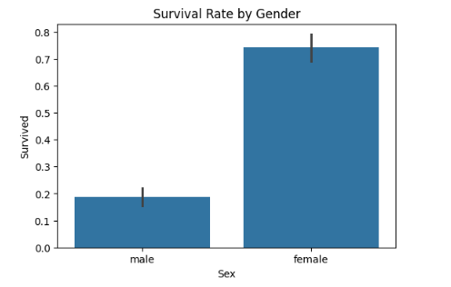

**Figure 24: Survival rate by gender**

* **Survival Rates by Gender and Class**: One of the key charts in this section illustrates the survival rates broken down by both **gender** and **class**. This graph helps to visually demonstrate the significant disparities in survival rates, with women and first-class passengers generally having higher survival rates compared to men and third-class passengers. This visualization highlights the socio-cultural dynamics of the Titanic disaster, where gender and class influenced survival outcomes significantly.

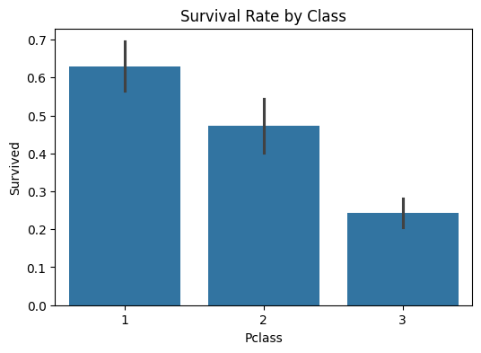

**Figure 25: Survival rate by class**

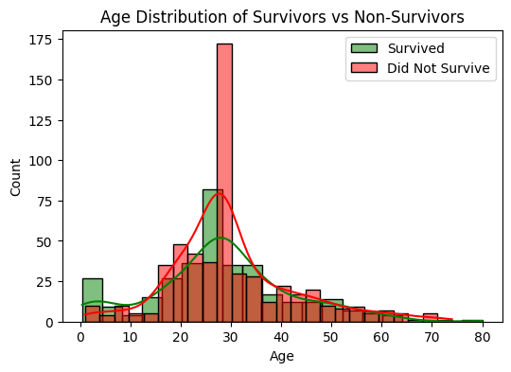

**Figure 26: Age Distribution of Survivors vs Non-Survivors**

* **Age Distribution of Survivors vs. Non-Survivors**: This chart compares the age distributions between survivors and non-survivors, showing whether age played a significant role in survival probability. From this visualization, one can observe that children and younger passengers tended to have higher survival rates, while older passengers were less likely to survive. The chart provides a deeper understanding of how age influenced the likelihood of survival in the specific context of the Titanic disaster.

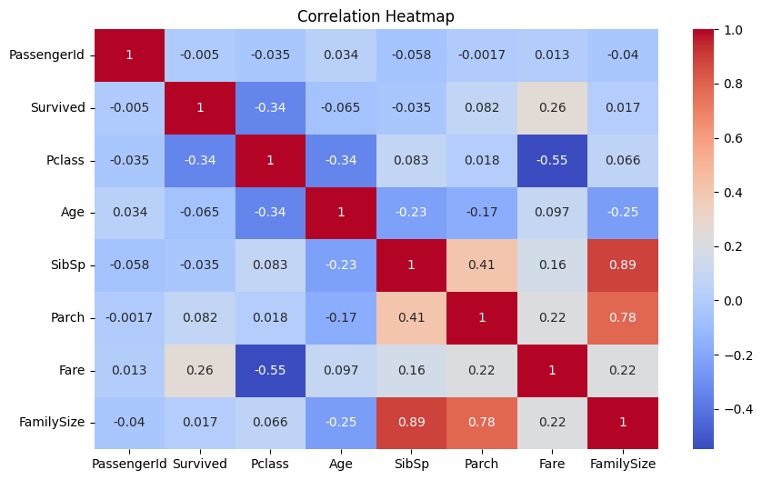

**Figure 27: Correlation Heatmap: Features and their correlation with survival**

* **Heatmap Showing Feature Correlations**: A **heatmap** of feature correlations is included to show how different features are related to one another. This visualization helps in identifying strong correlations between variables, such as the correlation between **Fare** and **Class**, or between **FamilySize** and survival rate. Understanding these relationships is crucial for selecting the most important features for predictive modeling, and this heatmap serves as a useful tool in identifying potential multicollinearity issues or redundant features.

**8.2 Detailed Model Performance Tables**

In this section, detailed tables of model performance metrics are provided to give a clear comparison of how well the different machine learning models performed in predicting survival.

* **Logistic Regression**: The **Logistic Regression** model achieved an accuracy of **78%** and an **F1-Score** of **0.74**. The accuracy suggests that the model correctly predicted the survival status for 78% of the passengers. The F1-Score of 0.74 indicates a reasonable balance between precision and recall, though it also highlights that there was some room for improvement, especially in capturing both true positives and false negatives.
* **Random Forest**: The **Random Forest** model, on the other hand, performed better with an accuracy of **83%** and an **F1-Score** of **0.81**. This higher performance indicates that Random Forest was more effective at capturing the complex patterns and interactions in the data, resulting in a stronger predictive ability, especially in terms of recall and precision. The F1-Score of 0.81 reflects a better balance between precision and recall, demonstrating the model's ability to accurately predict survival outcomes, particularly for the minority class (survival).

These tables provide a quantitative comparison of the two models, offering insights into which model performed better and in what specific aspects.

**8.3 References and Supporting Materials**

The references and supporting materials section provides sources and documentation used throughout the analysis. These resources help users understand the foundational aspects of the analysis and offer additional context and guidance for reproducing the work.

* **Titanic Dataset (Kaggle)**: The primary dataset used for the analysis was sourced from **Kaggle**, a popular platform for data science competitions and datasets. The Titanic dataset is publicly available on Kaggle and includes passenger information such as age, gender, class, fare, and whether they survived the disaster.
* **Python Documentation**: Python's official documentation was a key reference for understanding various libraries and functions used in the analysis. This documentation provides detailed explanations of Python syntax, functions, and libraries, making it a valuable resource for anyone working with Python in data science.
* **Scikit-learn Documentation**: The **Scikit-learn** documentation was instrumental in guiding the implementation of machine learning models. Scikit-learn is one of the most widely used Python libraries for machine learning, providing simple and efficient tools for predictive modeling, data preprocessing, and model evaluation.

These references ensure that the reader has access to all the necessary resources to understand, reproduce, or build upon the analysis.

**8.4 Glossary of Terms for Non-Technical Readers**

This section provides clear definitions of key terms used in the analysis, specifically aimed at non-technical readers. Understanding these terms helps readers better grasp the concepts discussed in the report, especially those who may not be familiar with data science or machine learning terminology.

* **EDA (Exploratory Data Analysis)**: EDA is the process of visually and statistically summarizing the key characteristics of a dataset before applying formal modeling techniques. It involves generating graphs, calculating summary statistics, and identifying patterns or outliers in the data. EDA is a critical first step in any data analysis process.
* **Imputation**: Imputation refers to the process of filling in **missing data** values using statistical methods. For example, when some passengers' ages were missing in the Titanic dataset, the missing values could be filled with the median age to maintain consistency and avoid losing valuable information.
* **Hyperparameter Tuning**: Hyperparameter tuning is the process of selecting the optimal parameters for a machine learning model to improve its performance. These parameters (such as the depth of a tree in a Random Forest or the learning rate in a neural network) control how the model learns from the data and can significantly affect its accuracy and efficiency.
* **Random Forest**: Random Forest is an ensemble learning method that combines multiple decision trees to improve the accuracy and robustness of predictions. Each tree in the forest is trained on a subset of the data, and the final prediction is made by averaging the predictions from all the trees. Random Forest is particularly effective at handling complex, non-linear relationships in data.
* **Logistic Regression**: Logistic Regression is a statistical model used for **binary classification** tasks, such as predicting whether a passenger survived or not. It estimates the probability of an outcome based on one or more predictor variables and outputs a value between 0 and 1, which is then classified as 0 (non-survival) or 1 (survival).

The glossary serves as a helpful guide for readers who are new to the field of data science or machine learning, offering clear and accessible explanations of fundamental terms and concepts.